Mata Kuliah : Pemograman Internet – TI – S1

Pertemuan : 6

NIM : A11.2014.08181

Nama : Firly Septian

Hasil Program :

Beranda (main.html)

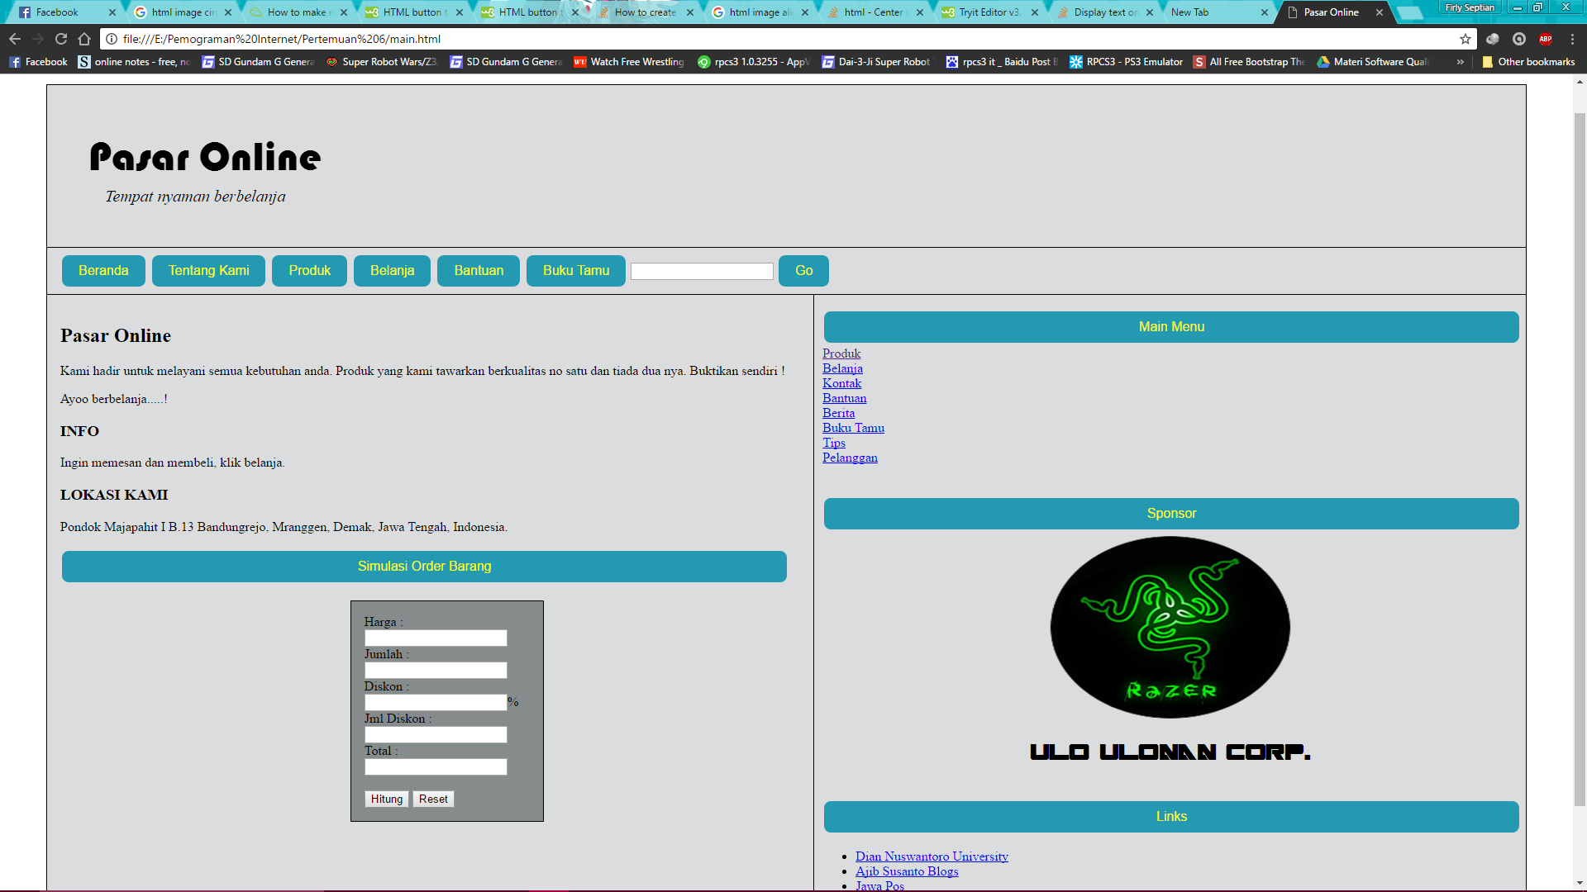

Tentang Kami (about.html)

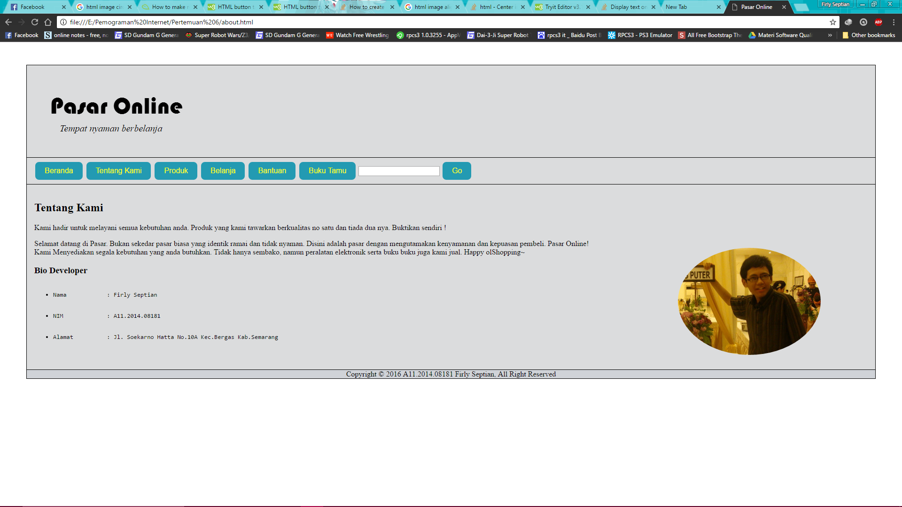

Produk (produk.html)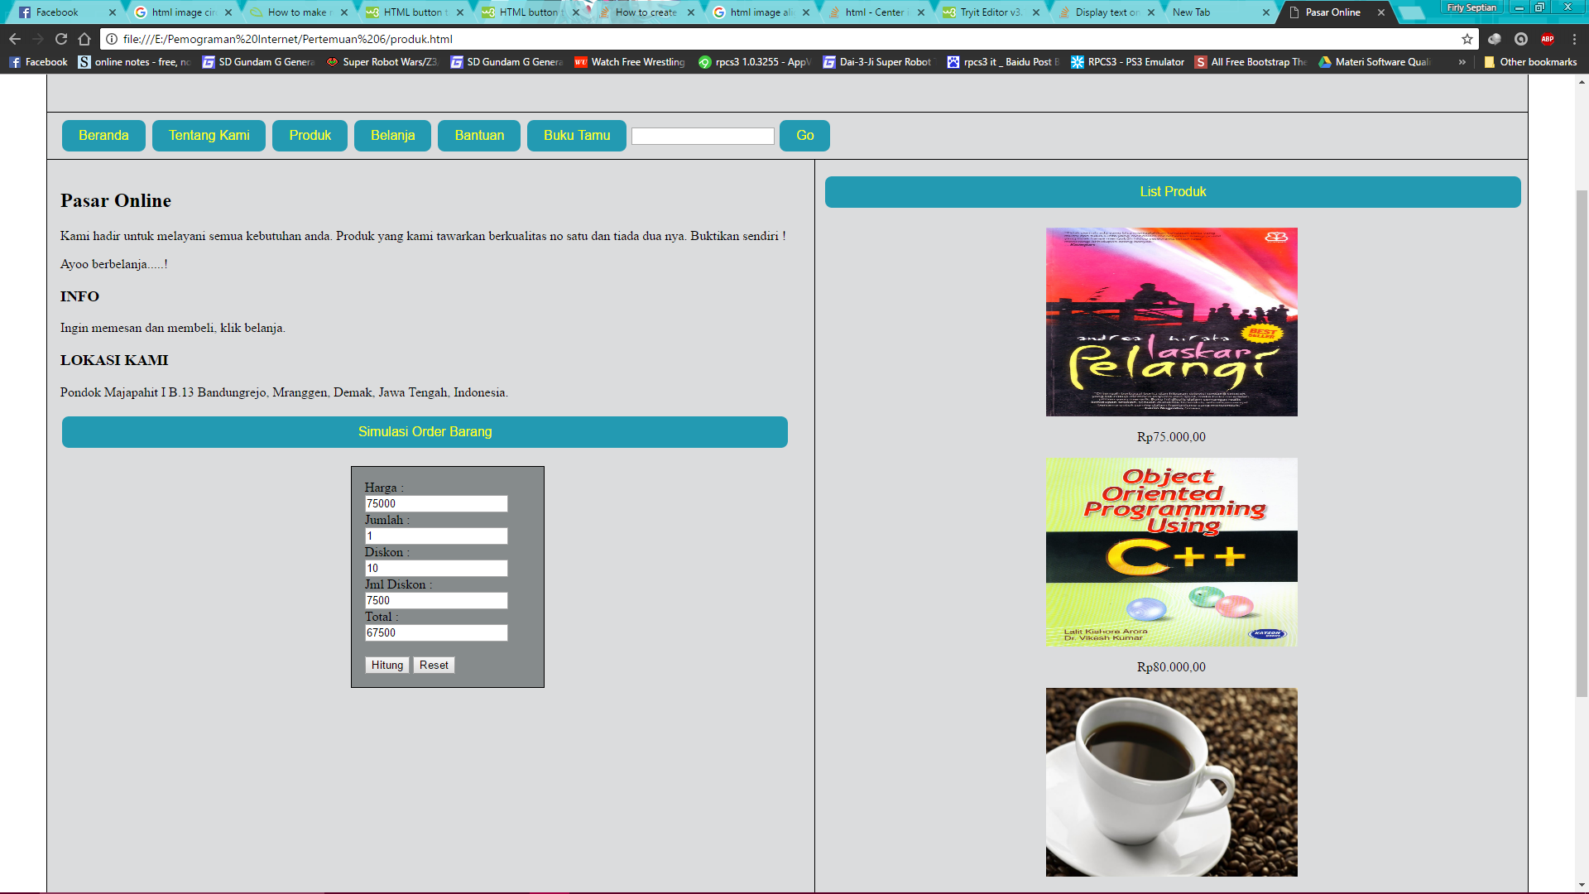

Code Program :

#MAIN

<html>

<head>

<style>

div.container{

margin-left:3em;

margin-right:3em;

margin-top:3em;

border: 1px solid black;

overflow:auto;

background-color:#dbdcdd;

}

p.header{

padding-left:1em;

font-family:"Bauhaus 93";

font-size:50px;

}

p.side{

font:"Bauhaus 93";

}

i.sub{

font-family:"times new roman";

font-size:20px;

margin-left:1em;

}

nav{

padding:5px 1em;

border:1px solid black;

border-left:0px;

border-right:0px;

}

button{

background-color:#239ab2;

border:none;

border-radius:8px;

color:yellow;

text-align:center;

margin:4px 2px;

padding:10px 20px;

font-size:16px;

}

.order{

width:100%;

}

.forms{

font-size:12px;

margin-top:10px;

padding:8px 8px;

}

article{

float:left;

padding:1em 1em;

}

form{

background-color:#868b8c;

padding:1em 1em;

margin-left:40%;

width:200px;

border:1px solid black;

}

aside{

float:right;

padding:1em 10px;

border-left:1px solid black;

width:47%;

}

.btnaside{

width:100%;

}

img{

width:304px;

height:228px;

}

div.footer{

margin-left:3em;

margin-right:3em;

border: 1px solid black;

text-align:center;

border-top:0px;

background-color:#d0d3d8;

}

</style>

<title>

Pasar Online

</title>

</head>

<body>

<div class="container">

<header>

<p class="header">Pasar Online<br>

<i class="sub">Tempat nyaman berbelanja</i></p>

</header>

<nav>

<a href="main.html"><button>Beranda</button></a>

<a href="about.html"><button>Tentang Kami</button></a>

<a href="produk.html"><button>Produk</button></a>

<button>Belanja</button>

<button>Bantuan</button>

<button>Buku Tamu</button>

<input name="search" type="text">

<button name="search_submit" type="submit">Go</button>

</nav>

<article>

<h2>Pasar Online</h2>

<p>Kami hadir untuk melayani semua kebutuhan anda.

Produk yang kami tawarkan berkualitas no satu dan tiada dua nya. Buktikan sendiri !

<p> Ayoo berbelanja.....!

<h3>INFO</h3>

<p> Ingin memesan dan membeli, klik belanja.

<h3>LOKASI KAMI</h3>

<p>Pondok Majapahit I B.13 Bandungrejo, Mranggen, Demak, Jawa Tengah, Indonesia.</p>

<button class="order">Simulasi Order Barang</button>

<br><br>

<form name="itungan">

Harga : <input type="number" name="harga" id="input1">

Jumlah : <input type="number" name="jumlah" id="input2">

Diskon : <input type="number" name="diskon" id="input3">%

Jml Diskon : <input type="number" name="ndiskon" id="output1">

Total : <input type="number" name="total" id="output2">

<br><br>

<input type="button" value="Hitung" onclick="kalkulasi();"/>

<input type="reset">

</form>

</article>

<aside>

<button class="btnaside">Main Menu</button>

<a href="produk.html">Produk</a><br>

<a href="www.ajibsusanto.blogspot.com">Belanja</a><br>

<a href="www.jawapos.co.id">Kontak</a><br>

<a href="www.jawapos.co.id">Bantuan</a><br>

<a href="www.jawapos.co.id">Berita</a><br>

<a href="www.jawapos.co.id">Buku Tamu</a><br>

<a href="www.jawapos.co.id">Tips</a><br>

<a href="www.jawapos.co.id">Pelanggan</a><br><br><br>

<button class="btnaside">Sponsor</button>

<center><img src="123.png" title="Rajer"></img></center>

<h2 style="font-family:cyberspace"><center>Ulo Ulonan Corp.</center></h2><br>

<button class="btnaside">Links</button>

<ul>

<li><a href="www.dinus.ac.id">Dian Nuswantoro University</a></li>

<li><a href="www.ajibsusanto.blogspot.com">Ajib Susanto Blogs</a></li>

<li><a href="www.jawapos.co.id">Jawa Pos</a></li>

<li><a href="www.detik.com">Detik</a></li>

<li><a href="about.html">Tentang Kami</a></li>

</ul>

</aside>

</div>

<div class="footer">

Copyright &copy 2016 A11.2014.08181 Firly Septian, All Right Reserved

</div>

<script type="text/javascript">

function kalkulasi(){

var inputharga=document.itungan.harga.value;

var inputjumlah=document.itungan.jumlah.value;

var inputdiskon=document.itungan.diskon.value;

outputndiskon=((inputharga*inputjumlah)/100)*inputdiskon;

outputtotal=inputharga*inputjumlah-(((inputharga*inputjumlah)/100)*inputdiskon);

document.itungan.ndiskon.value=outputndiskon;

document.itungan.total.value=outputtotal;

}

</script>

</body>

</html>

#PRODUK

<html>

<head>

<style>

div.container{

margin-left:3em;

margin-right:3em;

margin-top:3em;

border: 1px solid black;

overflow:auto;

background-color:#dbdcdd;

}

p.header{

padding-left:1em;

font-family:"Bauhaus 93";

font-size:50px;

}

p.side{

font:"Bauhaus 93";

}

i.sub{

font-family:"times new roman";

font-size:20px;

margin-left:1em;

}

nav{

padding:5px 1em;

border:1px solid black;

border-left:0px;

border-right:0px;

}

button{

background-color:#239ab2;

border:none;

border-radius:8px;

color:yellow;

text-align:center;

margin:4px 2px;

padding:10px 20px;

font-size:16px;

}

.order{

width:100%;

}

.forms{

font-size:12px;

margin-top:10px;

padding:8px 8px;

}

article{

float:left;

padding:1em 1em;

}

form{

background-color:#868b8c;

padding:1em 1em;

margin-left:40%;

width:200px;

border:1px solid black;

}

aside{

float:right;

padding:1em 10px;

border-left:1px solid black;

width:47%;

}

.btnaside{

width:100%;

}

img{

width:304px;

height:228px;

}

div.footer{

margin-left:3em;

margin-right:3em;

border: 1px solid black;

text-align:center;

border-top:0px;

background-color:#d0d3d8;

}

</style>

<title>

Pasar Online

</title>

</head>

<body>

<div class="container">

<header>

<p class="header">Pasar Online<br>

<i class="sub">Tempat nyaman berbelanja</i></p>

</header>

<nav>

<a href="main.html"><button>Beranda</button></a>

<a href="about.html"><button>Tentang Kami</button></a>

<a href="produk.html"><button>Produk</button></a>

<button>Belanja</button>

<button>Bantuan</button>

<button>Buku Tamu</button>

<input name="search" type="text">

<button name="search_submit" type="submit">Go</button>

</nav>

<article>

<h2>Pasar Online</h2>

<p>Kami hadir untuk melayani semua kebutuhan anda.

Produk yang kami tawarkan berkualitas no satu dan tiada dua nya. Buktikan sendiri !

<p> Ayoo berbelanja.....!

<h3>INFO</h3>

<p> Ingin memesan dan membeli, klik belanja.

<h3>LOKASI KAMI</h3>

<p>Pondok Majapahit I B.13 Bandungrejo, Mranggen, Demak, Jawa Tengah, Indonesia.</p>

<button class="order">Simulasi Order Barang</button>

<br><br>

<form name="itungan">

Harga : <input type="number" name="harga" id="input1">

Jumlah : <input type="number" name="jumlah" id="input2">

Diskon : <input type="number" name="diskon" id="input3">

Jml Diskon : <input type="number" name="ndiskon" id="output1">

Total : <input type="number" name="total" id="output2">

<br><br>

<input type="button" value="Hitung" onclick="kalkulasi();"/>

<input type="reset">

</form>

</article>

<aside>

<button class="btnaside">List Produk</button>

<center><img src="1.jpg" style="margin-top:20px" title="Novel Laskar Pelangi"></img></center>

<center><p>Rp75.000,00</p></center>

<center><img src="2.jpg" title="Pembelajaran C++"></img></center>

<center><p>Rp80.000,00</p></center>

<center><img src="3.jpg" title="kopi luwak"></img></center>

<center><p>Rp59.000,00</p></center>

<center><img src="4.jpg" title="Printer Canon"></img></center>

<center><p>Rp250.000,00</p></center>

</aside>

</div>

<div class="footer">

Copyright &copy 2016 A11.2014.08181 Firly Septian, All Right Reserved

</div>

<script type="text/javascript">

function kalkulasi(){

var inputharga=document.itungan.harga.value;

var inputjumlah=document.itungan.jumlah.value;

var inputdiskon=document.itungan.diskon.value;

outputndiskon=((inputharga*inputjumlah)/100)*inputdiskon;

outputtotal=inputharga*inputjumlah-(((inputharga*inputjumlah)/100)*inputdiskon);

document.itungan.ndiskon.value=outputndiskon;

document.itungan.total.value=outputtotal;

}

</script>

</body>

</html>

#ABOUT

<html>

<head>

<style>

div.container{

margin-left:3em;

margin-right:3em;

margin-top:3em;

border: 1px solid black;

overflow:auto;

background-color:#dbdcdd;

}

p.header{

padding-left:1em;

font-family:"Bauhaus 93";

font-size:50px;

}

i.sub{

font-family:"times new roman";

font-size:20px;

margin-left:1em;

}

nav{

padding:5px 1em;

border:1px solid black;

border-left:0px;

border-right:0px;

}

button{

background-color:#239ab2;

border:none;

border-radius:8px;

color:yellow;

text-align:center;

margin:4px 2px;

padding:10px 20px;

font-size:16px;

}

article{

padding:1em 1em;

}

img{

margin-right:100px;

float:right;

width:304px;

height:228px;

border-radius: 50%;

}

div.footer{

margin-left:3em;

margin-right:3em;

border: 1px solid black;

text-align:center;

border-top:0px;

background-color:#d0d3d8;

}

</style>

<title>

Pasar Online

</title>

</head>

<body>

<div class="container">

<header>

<p class="header">Pasar Online<br>

<i class="sub">Tempat nyaman berbelanja</i></p>

</header>

<nav>

<a href="main.html"><button>Beranda</button></a>

<a href="about.html"><button>Tentang Kami</button></a>

<a href="produk.html"><button>Produk</button></a>

<button>Belanja</button>

<button>Bantuan</button>

<button>Buku Tamu</button>

<input name="search" type="text">

<button name="search_submit" type="submit">Go</button>

</nav>

<article>

<h2>Tentang Kami</h2>

<p>Kami hadir untuk melayani semua kebutuhan anda.

Produk yang kami tawarkan berkualitas no satu dan tiada dua nya. Buktikan sendiri !

<p>Selamat datang di Pasar. Bukan sekedar pasar biasa yang identik ramai dan tidak nyaman. Disini

adalah pasar dengan mengutamakan kenyamanan dan kepuasan pembeli. Pasar Online!<br>

Kami Menyediakan segala kebutuhan yang anda butuhkan. Tidak hanya sembako, namun peralatan elektronik serta

buku buku juga kami jual. Happy olShopping~

<img src="https://pbs.twimg.com/profile_images/1881248168/DSC00823.jpg">

<h3>Bio Developer</h3>

<ul>

<pre>

<li>Nama : Firly Septian</li>

<li>NIM : A11.2014.08181</li>

<li>Alamat : Jl. Soekarno Hatta No.10A Kec.Bergas Kab.Semarang</li>

</pre>

</ul>

</article>

</div>

<div class="footer">

Copyright &copy 2016 A11.2014.08181 Firly Septian, All Right Reserved

</div>

</body>

</html>